HARPRIT SINGH

Conceptual Modelling

Assignment 1

Milestone 1

Contents

PAGES

1. CONCEPTUAL MODELING 3
2. CHEN ERD 5
3. PROJECT BRIEF ERD 14
4. DATA DICTONARY 16
5. ASSSUMED BUSINESS RULE 23

Conceptual Modeling

HISTORY OF CONCEPTUAL modeling

Three decades are represented in the conceptual modelling: the 1970s, 1980s, and 1990s.

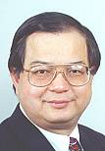

In the 1970s, database architecture was critical.

In the field of data modelling and database architecture, Peter Chen's paper "The Entity-Relationship Model: Toward a Unified View of Data" is a landmark.

Smith and Smith incorporate abstraction and generalization of database architecture.  
There have also been efforts to create high-level data definition languages for identifying and describing mathematical schemas.

The Conceptual Schema Language is one such language (CSL). Information structures and their semantics are becoming more fascinating.

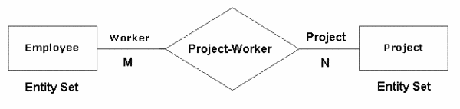

1980

Several approaches to extending Chen's Entity Relationship Model were established in the 1980s.We also look at the 1980 Pingree Park Workshop. Roland Colette's REMORA is another significant work from this decade. Really, information systems and their architecture are fascinating subjects.

1990

In the early 1990s, there were many issues in the field of database architecture, such as schema convergence, schema adaptation, and consistency controls for logical schemas. Object-oriented simulation approaches and languages in software engineering, however, have an impact on this period. Object-oriented programming languages became more popular in the 1980s.

In software engineering, data modelling is becoming increasingly relevant.

At the start of the 1990s, there were more than fifty different modelling languages available.

Booch, Jacobson, and Rumbaugh worked together to create the Unified Modeling Language (UML), which became a staple in object-oriented modelling in 1997.

According, designer wants their user to understand their models to make it perfectly they uses conceptual modelling. By using the software and documentation the users draw a rough diagram and gave it to the designer.

However, Conceptual models define structure models in terms of entities, relationships, and constraints, and behaviors or functional models in terms of states, transitions between states, and actions performed in states and transitions. Conceptual modelling is used to define the semantics of software applications at a high level of abstraction.

Structure models are defined in terms of entities, relationships, and constraints by conceptual models, while behaviors or functional models are defined in terms of states, transitions between states, and acts performed in states and transitions by behavioral models.

The conceptual data model is a business rules view of the data needed to support business processes, monitor relevant performance metrics, and document business events.

The emphasis of this model is on defining the data used in the sector, rather than the processing flow or physical characteristics. The viewpoint of this model is unaffected by any underlying business applications. It allows businesspeople to see sales data, cost data, clients, and goods, for example—all of which are business subjects in the integrated model but not in the applications themselves.

When creating a design model for a future software programme, one aim is to keep it as straightforward as possible. The fewer definitions that users must learn, the easier, if the requisite functionality is included.

Mind the following while developing computer applications, as well as many other things:

Mies van der Rohe once said, "Less is better."

Chen ERD Diagram:

The entity–relationship model (ER model) is a type of entity–relationship model.

This model is made up of object categories that all classify the so-called "things of interest." It represents the interrelated things of interest in a narrow domain of information.

Many of the relationships that may occur between instances of the entity types are defined in the model.

As I told earlier Peter Chen created entity–relationship modelling in 1976 with the aim of using it in database design.

Other ER-modelers insist on displaying subtype entities bound by generalization and specialization relationships, so the ER-model can be used to specify domain-specific concepts as well. This model does not describe certain business processes, but it does provide a graphical representation of a business data schema.

The ER model can be represented graphically in the form of boxes that represent entities and lines that represent relationships, representing interactions and connections between those entities.

"Entity-attribute-relationship diagrams" or "entity-relationship templates" are diagrams generated to display the necessary attributes and entities, as well as any relationships (which is not as common).

There are several different types of data models, the most common of which are "conceptual," "logical," and "real." There is the least grained complexity within the “conceptual” model (which is the highest degree possible of any ER model), which determines the general definition of what must be contained within the model set itself. This type of "conceptual ER model" is intended to describe the master reference data entities that are widely used by any company participating in the process.

This model can also be used as the basis for one or more logical data models, with the aim of establishing "structural metadata" between the various logical ER models. An ER model is implemented by a database. Remember that this ER model can be used to create commonality relationships between related models and serve as a foundation for further data model integration.

EXAMPLE:

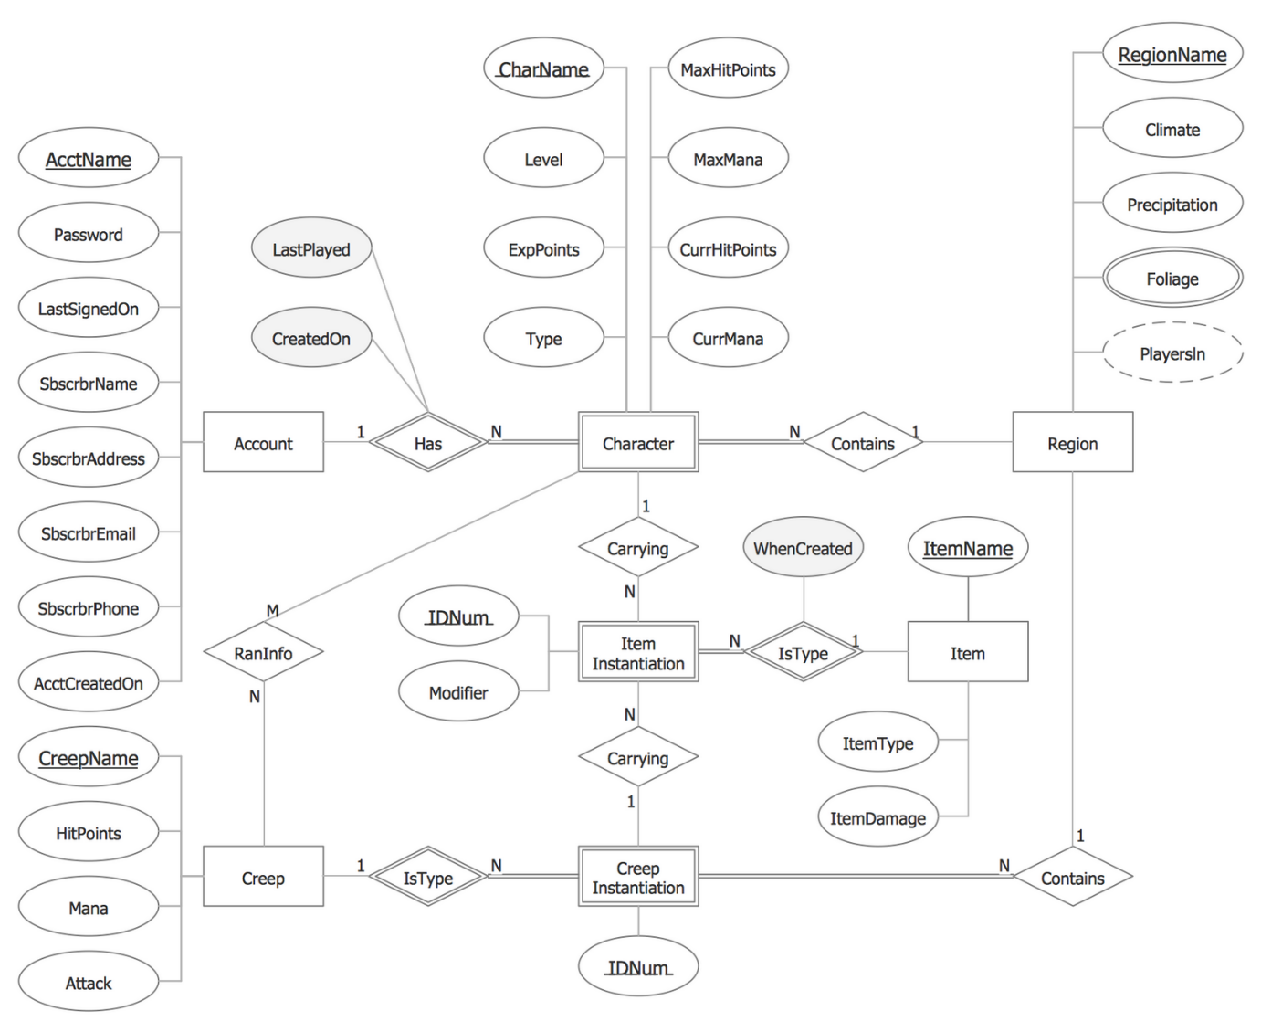

Here I will explain about explain more accurate components of ERD

1. Entity:

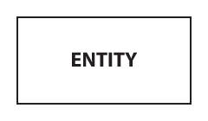

It is represented by rectangle shape and contains entities name in it.

1. Weak entity

An entity that cannot be defined solely by its attributes. The presence of a weak entity is contingent on the existence of another entity known as the owner entity. The identifier of the weak entity is a mixture of the owner entity's identifier and the weak entity's partial key.

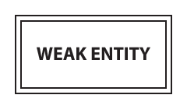

1. Associative entity:

In a many-to-many relationship, an entity will be included (represents an extra table).

Many of the associative entity's relationships should be many.



1. Attributes:

Each attribute is represented by an oval containing atributte’s name: and its connected with straight lines

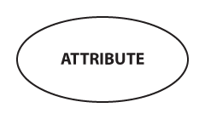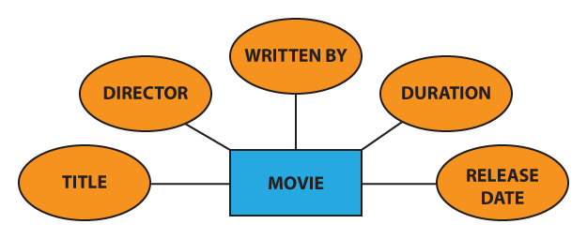

1. Key attribute:

A characteristic that distinguishes a certain person in a special way.

A main attribute's name is underlined and below is the example:

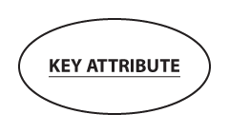

example 2: Since the Vehicle Identification Number (VIN) is a one-of-a-kind code used to classify particular vehicles (no two have the same VIN), “VIN” can be considered a key attribute for the “CAR” entity:

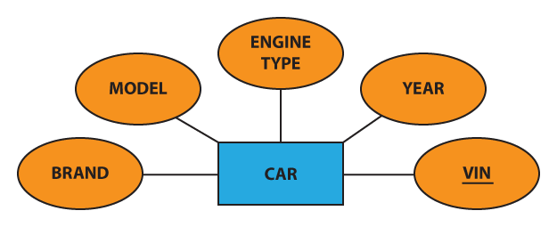

1. PARTIAL KEY attribute:

an attribute that, when paired with the owner entity's main attribute, gives the weak entity a unique identifier. With a dotted thread, we emphasize the discriminator:

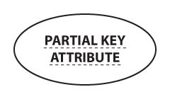

1. Multivalued Attribute:

an attribute with a wide range of possibilities (there are many distinct values entered for it in the same column of the table).A dual oval represents a multivalued attribute:

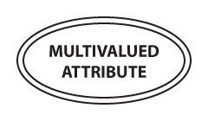

Example: each person can have several hobbies, the “hobby” attribute for the “user” object may be thought of as a multivalued attribute:

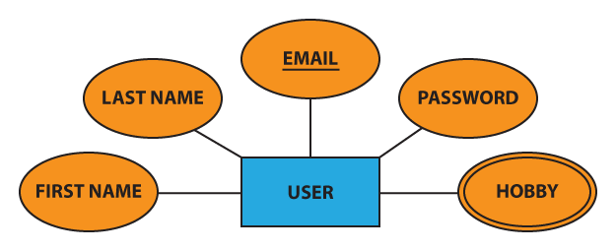

1. Derived Attribute:

an attribute whose value is obtained (calculated) from the values of other attributes.

The database may or may not physically store the derived attribute.

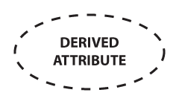

This attribute is represented by a dotted oval in Chen notation.

Example: For example, we can determine the price including VAT if we know the price excluding VAT and the VAT rate:

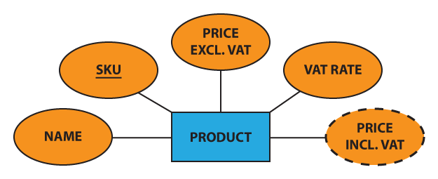

1. Composite attribute: Some attributes can be further divided into more smaller parts. These smaller parts are known as composite attribute.

Example: Address can be broken down into street name, street number, apartment number, area, state, zip code, and country.

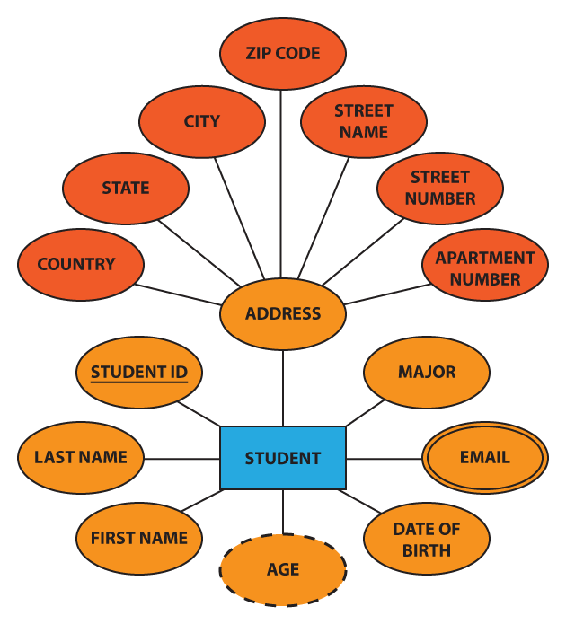

Relationship: A relationship is defined in Chen notation by a diamond (rhombus) bearing the relationship's name and it is divide into two parts which are explain below:

1. Strong relationship: a relationship in which an individual's presence is unaffected by the existence of other entities, and the PK of the Child does not include the PK attribute of the Parent Entity. A single rhombus represents a close relationship:



1. WEAK Relationship: a relationship in which the presence of the Child Entity is contingent on the existence of the Parent Entity, and the PK of the Child Entity comprises the PK attribute of the Parent Entity. A double rhombus represents this relationship:



Optionality of Relationship:

1. Using a solid line a mandatory relationship is represented:



1. Using dashed line optional relationship is represented:



Cardinality: Characters "1," "N," or "M" are normally inserted at the ends of relationships to denote the degree of relationship (cardinality):

1. ONE TO ONE ((1:1)):

Each employee can only oversee one department, and each department can only have one manager.

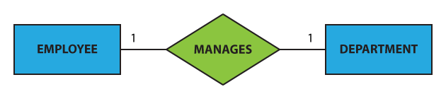

1. One to many (1:N):

Although a customer can place several orders, each order may only be placed by one customer:

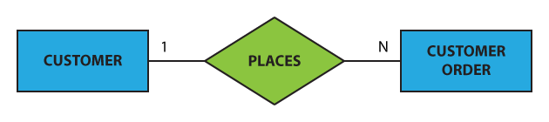

1. Many to one (N:1)

Many workers can be assigned to one department, but each employee may only be assigned to one department.

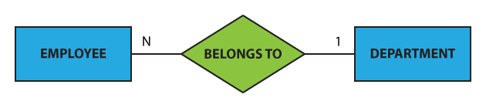

1. Many to many:

A student may be a member of multiple student organizations, and one group can accept multiple students



Total participation:

means that each person in the set is interested in the relationship; for example, each pupil must be supervised by a professor (there are no students who are not guided by any professor).

This type of relationship is represented by a double line in Chen notation.

Partial Participation:

means that not every entity in the set is interested in the relationship; for example, not every professor directs a student (some professors do not).

A single line in the Chen notation represents a partial presence.

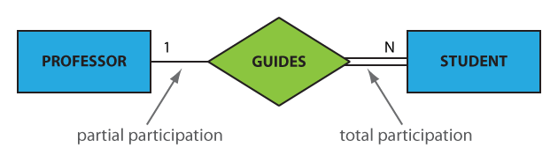

According to the above relationship, each student must be led by a single professor, and one – but not any – professor will direct several students.

So, there is no student who is not directed by a professor, and there are professors who do not instruct any students on the other side.

ERD:

https://github.com/Harprit-singh/DAT601-conceputal-diagram.git

Pls open this link it contains proper image.

Explaining the diagram:

Flight stream is an organization which provides video streaming and data sensing to government services, commercial organizations, and presence services. To provide their service they use, drones so that the drone can collect, sense data and transmitting too. For doing this all stuff we need more people which we work in a team but in different area. So, I divide the company into four parts which are

1) Staff member

2) Salesperson

3) Admin executive

4) Maintenance

Flight stream provides their contract in form of subscription service and the person who buy the subscription is known as subscriber. So here role of staff person is to handle the contracts which has many subscription services for subscribes and to provide the benefits to different types of subscribers they have.

I further divided it into super platinum, platinum, gold and standard. All of these are related to each with their attributes.

Salesperson: The name itself says the role he does. The role of salesperson is to sale subscriptions to the customers. The role of Admin executive is to maintain records between the data scoop and can change the price of subscription and can enter contract details. Maintenance person plays an important role of maintaining records for each drone data, supplier details, maintenance report. Flight stream drone has website for video steam for their subscriber. Video stream is providing views in 3d video form and for super platinum subscriber they gets full control to it.

Datascoop sense different stuff like: Temperature, Humidity, Ambient light strength and it fly’s around the world and can be configured different regions like Mountain, Snow, Desert and urban deployment and data is stored. The drone shows the live location and the datascoop data stores the data which the drone is sending. Flight stream deploys many drones to many zones

Data Dictionary:

**Conceptual Model Documentation**

**Table 1: Document Entities**

|  |  |  |  |
| --- | --- | --- | --- |
| **Entity Name** | **Description** | **Aliases** | **Occurrence** |
| Flight stream | Flight stream is the company name |  | Flightstream |
| Employees | Employees of the flight stream with unique id with different working sector | Flight stream |  |
|  |  |  |  |
| Administrative executive | Administrative executive will keep the records of the data and make changes to contract and subscription too | Flight stream |  |
| Data scoop | Data scoop will the shows details of data he senses | Data scoop |  |
| Video stream | Video stream will work with drone to provide video on their website |  |  |
| gold | Just a give weak entity which shows that type subscriber | subscriber |  |
| platinum | Just a give weak entity which shows that type subscriber | subscriber |  |
| Super platinum | Just a give weak entity which shows that type subscriber | subscriber |  |
| standard | Just a give weak entity which shows that type subscriber | subscriber |  |
| Datascoop data | Collect the data from the drone | Datascoop |  |
| Maintenance Person | Maintain the records, drone data, supplier parts . |  |  |
| Staff member | Shows details and handles the contracts of the company. | Staff member |  |
|  |  |  |  |
| Sale person | The person who sells the subscription as well as drones too |  |  |
|  |  |  |  |
| Data scoop parts | Details of data scoop parts | Data scope drone |  |
| supplier | Suppliers’ details who supply them drone parts |  |  |
| Website | A website for everyone | Flight stream |  |
| Subscription | Handling between subscribers and contract |  |  |
| zone | Zone are bounded by geographic regions | Data scoop |  |

**Table 2: Document Relationships**

|  |  |  |  |  |
| --- | --- | --- | --- | --- |
| **Entity Name** | **Cardinality** | **Relationship** | **Cardinality** | **Entity Name** |
| website | 1 | provides | N | Video stream |
| Video stream | M | Records | 1 | Data scoop |
| Gold | N | Control view | 1 | Video stream |
| Platinum | 1 | Less control | N | Data scoop |
| Super platinum | 1 | Exclusive control | 1 | Data scoop |
| Standard | 1 | View | N | Video stream |
| Subscription | 1 | has | M | Subscriber |
| Subscription | N | Provides | M | Contracts |
| Contracts | N | Handles | M | Staff member |
| Subscription | n | Sells | M | Salesperson |
| Maintenance person | 1 | Maintain records | M | Datascoop drone parts |
| Maintenance person | 1 | Maintain records | N | Datascoop data |
| Flight stream | 1 | has | m | Employees |
| Datascoop | N | Transmit | 1 | Datascoop data |
| Data scoop drone part | M | Supplies | N | Supplier |
| Data scope | n | Bounded by | m | zone |
| Subscription | N | Sales | N | Salespersons |
| contract | N | Enter | 1 | Admin executive |

**Table 3: Document Attributes**

| **Entity Name** | **Attributes** | **Description** | **Domain** | **Aliases** | **Composite** | **Derived** | **Nulls** | **Key?** | **Default Value** |
| --- | --- | --- | --- | --- | --- | --- | --- | --- | --- |
|  | Video time | Duration of time | number |  |  | no | no |  | - |
|  | Video id | Unique number | - | Video stream | no | no | no | CK/PK | - |
|  | Video quality | Quality of video | number |  | no | no | no | - | - |
| **Video stream** | Video details | details | Char string |  |  | no | No |  | - |
|  | GOLD sub Id | Unique id | - |  |  |  |  |  | - |
|  | Gold sub name | Name of gold sub | Char string | Gold subscriber | no | no | No | - | -- |
| **Gold sub** | Gold sub details | Details of gold sub | Char string |  |  | no | no | - | - |
|  | Gold sub fees | Fees of gold sub | number |  |  | no | no | - | - |
|  | Platinum sub id | Unique id | - |  |  |  |  |  | -- |
|  | Platinum sub name | Name of platinum sub | Char string |  |  | no | No | - | - |
| **Platinum sub name** | Platinum sub details | Details of platinum sub | Char string | Platinum sub |  | no | No | - | - |
|  | Platinum sub fees | Fees of Platinum sub | number |  |  | no | No | - | - |
|  | Super platinum id |  |  |  |  |  |  |  | - |
|  | Super platinum name | Super platinum name | Char string |  |  | No | No | - | - |
| **Super platinum** | Super platinum fees | Payment of super platinum | Char string | Super platinum |  | No | no | - | - |
|  | Super platinum  details | Details of super platinum | number |  |  | No | no | - | - |
|  | Standard id | Unique id | - |  |  |  |  |  | - |
| **Standard** | Standard name | Name of standard user | Char string | Standard |  | no | no | - | - |
|  | Standard fees | Standard fees | number |  |  | No | No | - | - |
|  | Standard details | Standard details | Char string |  |  | No | No | - | - |
|  |  |  |  |  |  |  |  |  | - |
|  | Contract id | Unique number | - | Contract |  | No | No | CK/PK | - |
| **Contract** | Contract details | Details of contract | Char string |  |  | No | No | - | - |
|  | Contract type | Type of contract | Char string |  |  | no | No | - | - |
|  |  |  |  |  |  |  |  |  | - |
|  | Datascoop id | Unique number |  |  |  | No | No | - | - |
|  | Altitude | Details of altitude | number |  |  | NO | No | - | -- |
| **Datascoop drone data** | Light strength | Details of light strength | number | Datascoop  drone data |  | No | No | - | - |
|  | temperature | Details of temperature | number |  |  | No | No | - | - |
|  | Humidity | Details of humidity | number |  |  | no | No | - | - |
|  |  |  |  |  |  |  |  |  | - |
|  |  |  |  |  |  |  |  |  | - |
| **Flight stream** | Flight stream id | Unique id | - |  |  | No | no | Pk | - |
|  | Flight stream address | Address of the company | Char string | Flight stream | Street, postal code. | No | no | - | -- |
|  | Flight stream phoneno | Phone no the company | number |  |  | No | No | - | - |
|  |  |  |  |  |  |  |  |  |  |
|  | Admin id | Unique id | - |  |  | no | No | PK | -- |
| **Admin executive** | Admin details | Details of his information | Varchar string | Admin executive | First name, last name, email address | no | no | - | - |
|  | Admin records | Reports of everything | Char |  |  | no | No | - | - |
|  | Subscriber id | Unique id | - |  |  | no | No | Pk | - |
| **subscriber** | Subscriber password | Password of subscriber | Char string | subscriber |  | no | no | - | - |
|  | Subscriber details | Details of subscriber | Char string |  |  | no | No | - | - |
|  |  |  |  |  |  |  |  |  |  |
|  | Datascoop id | Unique no | - |  |  | no | no | PK | - |
|  | Altitude | Details of altitude | number |  |  | no | no | - | - |
|  | humidity | Details of humidity | number |  |  | no | no | - | -- |
|  | latitude | Details of latitude | number |  |  | no | No | - | - |
|  | Light strength | Details of light strength | number |  |  | No | no | - | -- |
| **Datascoop drone** | location | Details of location | Number | Datascoop drone |  | No | no | - | - |
|  | longitude | Details of longitude | number |  |  | No | no | - | -- |
|  | temperature | Details of temperature | number |  |  | No | no | - | - |
|  |  |  |  |  |  |  |  |  |  |
|  |  |  |  |  |  |  |  |  |  |
|  |  |  |  |  |  |  |  | - |  |
|  | Subscription id | Unique id | - |  |  |  |  | PK |  |
|  | Subscription type | Types of subscription | Char string |  |  | no | No | - | - |
| **Subscription** | Subscription details | Details of subscription | Char string | subscription |  | no | No | - | - |
|  | Subscription fees | Price of subscription | number |  |  | No | no | - | - |
|  | Staff id | Unique number | - |  |  | No | No | PK | -- |
|  | Staff first name | Tells you the first name of staff | Char string |  |  | No | no | - | - |
| **Office Staff member** | Staff address | Let you know the staff address | Char string | Staff address | Street name, Postal code | no | no | - | - |
|  | Staff details | Provide more details of the staff | Char string |  |  | No | No | - | - |
|  | Staff email address | Staff email address | Char string |  |  | No | no | - | - |
|  | Staff phone no | Phone number of staff to contact him | number |  |  | No | No | - | - |
|  | Staff last name | Last name of the staff | Char string |  |  | no | No |  |  |
| **Maintenance person** | Maintenance person Id | Unique number | Char string | Technician |  | No | no | - | - |
|  | Maintenance person last name | Last name | Char string |  |  | No | No | - | - |
|  | Maintenance person first name | First name | - |  |  | No | No | - | - |
|  |  |  |  |  |  |  |  | - |  |
| **Datascoop drone parts** | Datascoop drone part details | Details of drone parts | Char string |  |  | No | No | - | - |
|  | Datascoop drone ID | Unique no | - |  |  | no | No | PK | - |
|  |  |  |  |  |  |  |  |  |  |
| **supplier** | Supplier ID | Unique no | - |  |  | No | no | Pk | - |
|  | Supplier name | Name of the supplier | Char string |  |  | No | no | - | - |
|  | Supplier phone no | Phone no of supplier | Number |  |  | No | No | - | - |
|  | Supplier email | Email address of supplier | Email @ |  |  | No | No | - | - |
|  |  |  |  |  |  |  |  |  |  |
|  | Salesperson id | Unique number | - |  |  | No | no | Pk | - |
| **salesperson** | Salesperson first name | First name of sale person | Char string | salesperson |  | No | no | - | -- |
|  | Salesperson last name | Last name of salesperson | Char string |  |  | No | No | - | - |
|  | Salesperson phone no | Sale person phone no | Number |  |  | no | no |  |  |
|  | Sales person email address | Email address of salesperson to send him sale to him | email |  |  | no | no |  |  |
| **Website** | WEBSITE ID | Unique number | - | Website | no | no | no | pk |  |
|  | Website details | Details covering everything of the website |  |  |  | no | no |  |  |
|  |  |  |  |  |  |  |  |  |  |
| **Zone** | Zone id | Unique id | - | Zone |  | no | no | PK |  |
|  | Zone area | Areas which cover the zone | Varchar |  |  | no | no |  |  |
| **Employees** | Employees id | Unique id | - | Employees |  | no | no | Pk |  |
|  | Employees details | Details of employee |  |  |  | no | no |  |  |
|  |  |  |  |  |  |  |  |  |  |

Assumption business rule: Business rule is quite good but it more costly. Depends on their sale.